# HW8

# Wenhui Yang

# 2/23/2019

############################################

**# Exercise 1**

mtcars

nrow(mtcars)

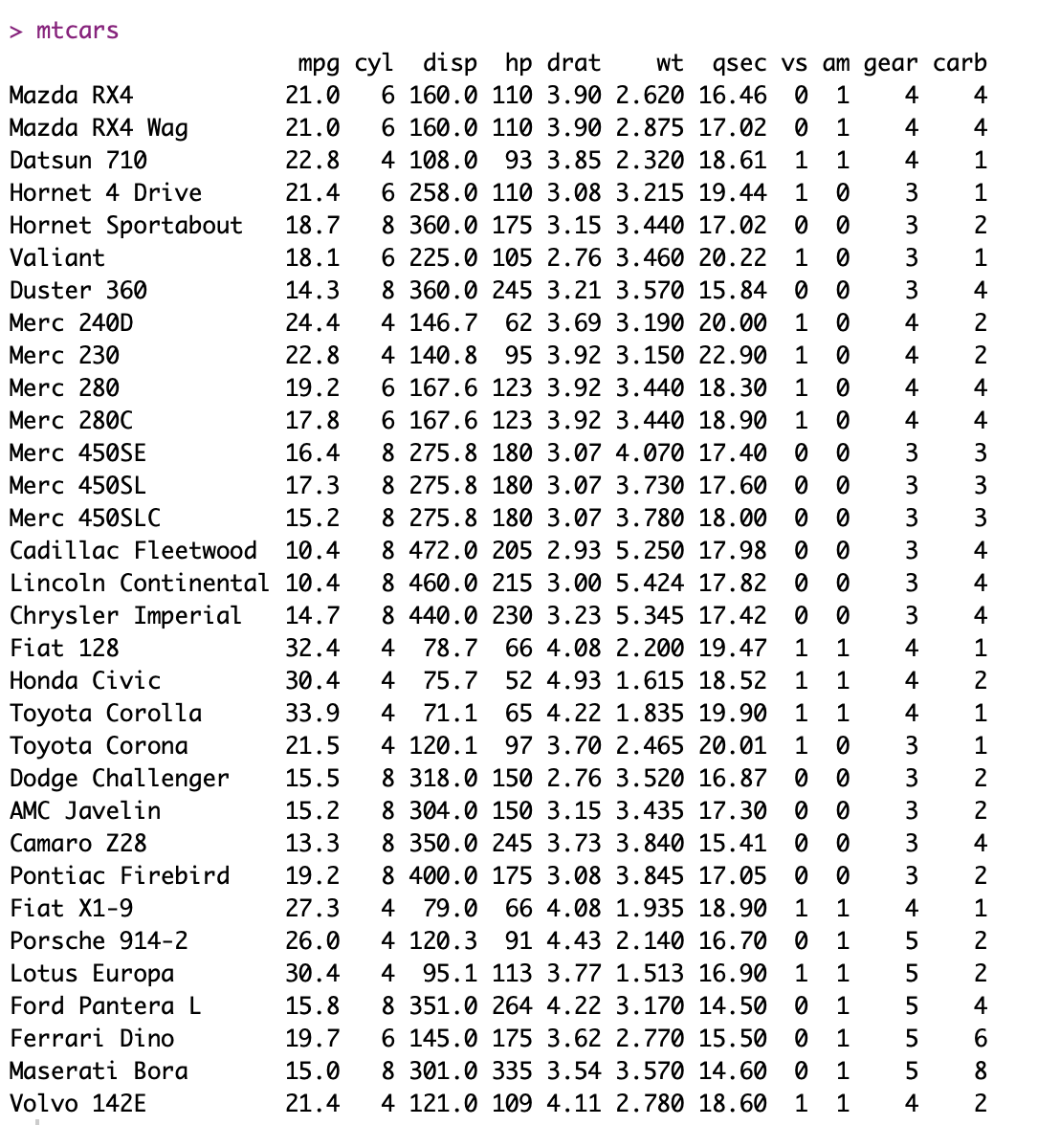

> nrow(mtcars)

[1] 32

a <- which(rownames(mtcars)=="Cadillac Fleetwood")

mtcars1 <- mtcars[1:a-1,]

mtcars2 <- mtcars[-(1:a-1),]

mtcars2[,c("vs","am")] <- NULL

mtcars2$vs <- NA

mtcars2$am <- NA

rbind(mtcars1,mtcars2)

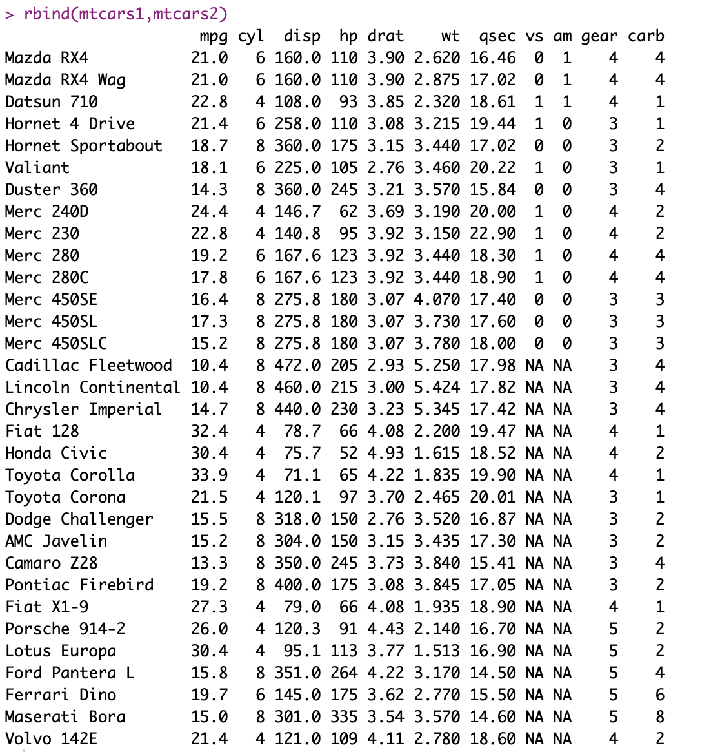

############################################

**#** **Exercise 2**

b <- which(colnames(mtcars)=="wt")

mtcars3 <- mtcars[,1:b-1]

mtcars4 <- mtcars[,-(1:b-1)]

mtcars4 <- mtcars4[!(substr(rownames(mtcars),1,4)=="Merc"),]

mtcars4

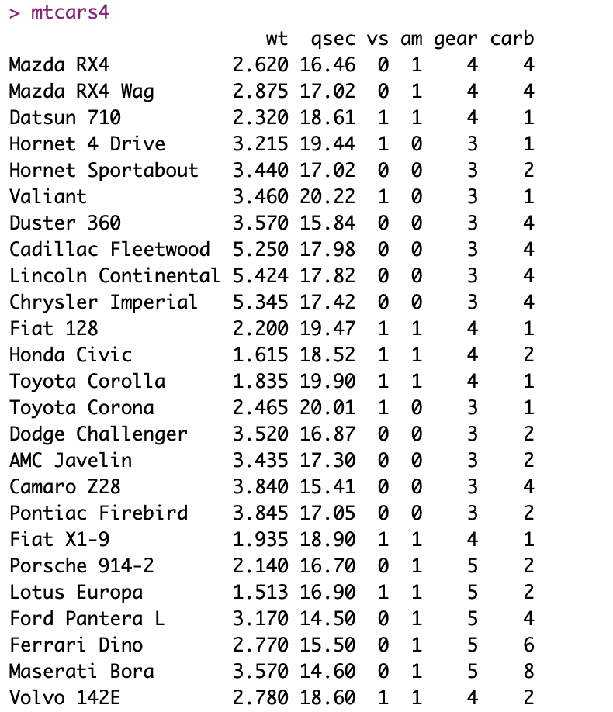

mtcars3$name <- row.names(mtcars3)

mtcars4$name <- row.names(mtcars4)

row.names(mtcars3) <- NULL

row.names(mtcars4) <- NULL

mtcars_all <- merge(mtcars3,mtcars4,by="name",all=TRUE)

mtcars_all

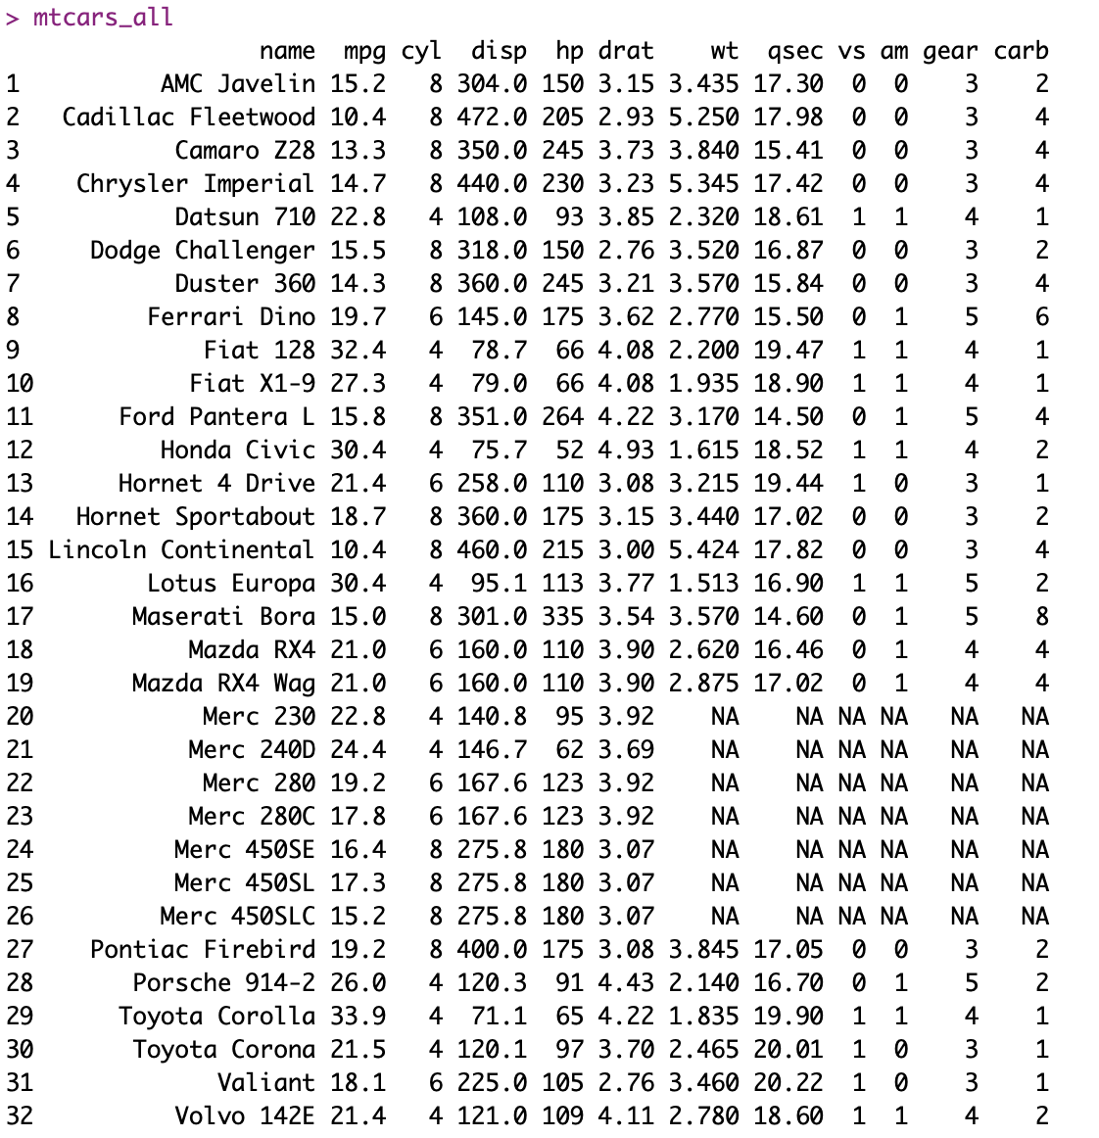

############################################

**# Exercise 3**

mov <- "The Shining"

act <- c("Jack Nicholson", "Shelley Duvall", "Danny Lloyd", "Scatman Crothers", "Barry Nelso")

scores <- c(4.5, 4.0, 5.0)

sources <- c("IMDb1", "IMDb2", "IMDb3")

comments <- c("Best Horror Film I have ever seen", "A truly brilliant and scary ESAim from Stanley Kubrick","A masterpiece of psychological horror")

rev <- data.frame(scores, sources, comments)

shine_list <- list(mov, act, rev)

rm(mov, act, scores, comments, rev)

names(shine_list) <- c("moviename", "actors","reviews")

shine_list

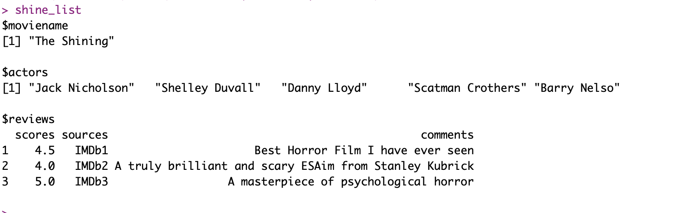

firsts <- shine_list[[2]][c(2,4)]

firsts

> firsts

[1] "Shelley Duvall" "Scatman Crothers"

actors <- shine_list[[2]][2]

actors

> actors

[1] "Shelley Duvall"

comment <- shine_list[[3]]

comment

> comment

scores sources comments

1 4.5 IMDb1 Best Horror Film I have ever seen

2 4.0 IMDb2 A truly brilliant and scary ESAim from Stanley Kubrick

3 5.0 IMDb3 A masterpiece of psychological horror

s5 <- shine_list[[3]][3,]

s5

> s5

scores sources comments

3 5 IMDb3 A masterpiece of psychological horror

release <- c("1980")

shine_list$release <- release

shining_list_new <- shine_list

shining_list_new

